Breakfast
Available 8am-11.30am

Eggs on Toast 12
Free range eggs (fried, poached or scrambled) served with your choice of
Sourdough or Gluten free (+1)

Lewers Big Breakfast 22
Free range egg, Trunkey Creek bacon, Italian pork sausage, mushrooms, hash brown, roast tomato & relish w/ toasted sourdough (gfa)

Vegetarian Mezze Plate 22
Free range egg, corn & zucchini fritter, hummus, halloumi, mushrooms, hash brown, tomato relish, zataar & roast tomato on toasted sourdough (gfa)

Strawberry & Cream Waffles 21
W/ Spring strawberries, raspberry compote, rosewater syrup, pistachio & vanilla mascarpone

Benedict 18
W/ Free range eggs, hollandaise on toasted sourdough (gfa)
Choice of:
- Smoked Salmon
- Trunky Creek bacon
- Haloumi

Mushies & Poached Eggs 19
w/ Pork & fennel sausage, crispy potatoes, spring vegetables, rocket, walnut pesto & zataar (gfa)

Sides

Grilled Haloumi 6
Trunkey Creek Bacon 6
Smoked salmon 5
Italian pork sausage 4
Avocado 4
Sautéed Mushrooms 4
Hash Brown 3
Corn & Zucchini Fritter 3
Tomato relish 2
Roast tomato 2
Hollandaise 2
Free Range Egg 2

Lunch
Available from 11.30am-2pm

French Chicken Salad 23
w/ Grilled chicken, baby potatoes, green beans, olives, heirloom tomatoes, capers & eschallot with a French vinaigrette (gf)

Smoked Salmon Linguini 23
w/ Asparagus, herb, garlic, capers, lemon & extra virgin olive oil

Lewers Steak Sandwich 21
w/ Vintage cheese, tomato, beetroot, onion, rocket, BBQ sauce & truffle aioli on toasted ciabatta roll
Served with fries
Add Bacon $2

Grilled Spiced Eggplant 20
w/ Moroccan hummus, cashew zataar, herb & brown rice salad
(gf/v)

Prosciutto & Melon Salad 20
w/ Feta, stone fruit, hazelnut & maple dressing
(gf)

All Day Menu
Available 8am-2pm

Smashed Avo 17
w/ Feta, herb & sprout salad, cashew zataar & lemon on toasted sourdough
(gfa)

Brekkie Burger 17
Trunkey Creek bacon, free range egg, truffle aioli, BBQ sauce & garden leaf on a toasted roll (gfa)
Add hash brown 3

Mixed Grain Granola & Yoghurt 18
w/ Seasonal fruit & honey (gf)

Corn & Zucchini Fritters 17
w/ Moroccan hummus, tomato chutney, cashew zataar, sprout salad, lemon & herbs
(gf, v)
Add Smoked Salmon 5
Add Haloumi 6

Italian Bruschetta 16
w/ Heirloom tomatoes, eschallot, walnut & rocket pesto, feta, dried olives & basil oil on Sonoma sourdough (2 pieces)
(gfa)
Add Prosciutto 4

Shoestring Fries w/ truffle aioli 8

Kids Menu

Bacon & egg on toast 9
Kids muesli tea cup w/natural yoghurt 8
Kids waffle w/ maple syrup, strawberries and ice cream 11
Cinnamon toast 7
Kids nuggets & fries 10

Sweets
Please ask our friendly staff about today’s cake varieties

Daily baked muffin 6

Banana bread 8
Toasted w/ honey and butter

(gf) Gluten Free
(gfa) Gluten Free Available
(v) Vegan

Please inform staff of any allergies or intolerances

10% Surcharge on Sundays and Public Holidays

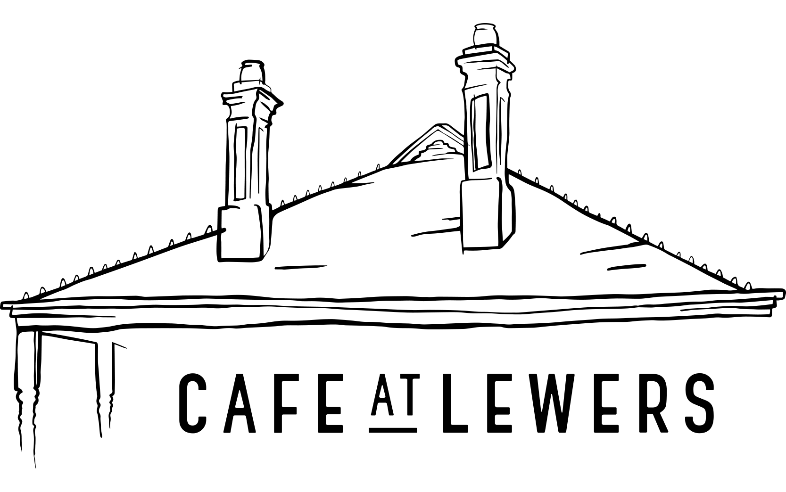
Follow Café at Lewers online

