Silent Auction – Warwick Fuller Artworks – Bidding form
The Friends of Penrith Regional Gallery, Home of The Lewers Bequest are holding a silent auction for two artworks by famous Australian landscape painter, Warwick Fuller. Funds raised will go towards the conservation of the remarkable modernist sculptures within the Gallery’s Heritage Garden. Auction closes 30 November 2020.
How to Bid
Nominate the amount you wish to bid by filling out the form provided. Please note the minimum reserve for each work, the oil painting and the etching. Fold and place the form in the auction bid box.

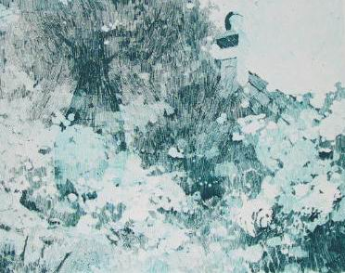

Warwick Fuller – Winter Garden, 1981 etching on paper, 20 x 25cm (one copy is framed as displayed and 7 unframed). Market value $300, minimum reserve $200.
On display in Gallery Reception
Name:
Phone number:
Email:
I would like to bid ……………………………………………………………………………….

